**SYNOPSIS**

COURSE CODE : - MCSP-060

Title Of The Project

**ONLINE VOTING SYSTEM**

**Introduction**

“ONLINE VOTING SYSTEM” is an online voting technique. In this system people who have citizenship of India and whose age is above 18 years of age and any sex can give his\her vote online without going to any physical polling station.

There is a database which is maintained in which all the names of voters with complete information is stored. In “ONLINE VOTING SYSTEM” a voter can use his\her voting right online without any difficulty. He\She has to be registered first for him/her to vote.

The system Administrator registers the voters on a special site of the system visited by him only by simply filling a registration form to register voter.

Citizens seeking registration are expected to contact the system administrator to submit their details. After the validity of them being citizens of India has been confirmed by the system administrator by comparing their details submitted with those in existing databases such as those as the Registrar of Persons, the citizen is then registered as a voter. After registration, the voter is assigned a secret Voter ID with which he/she can use to log into the system and enjoy services provided by the system such as voting. If invalid/wrong details are submitted, then the citizen is not registered to vote.

**Objective**

The main objectives of system for Online voting system are:

* The objective of Online voting system is to help the organization in automating the whole manual processing of the existing system.
* The main objective to develop the system is to make the accurate &amp; efficient decisions in different tasks at different time at different situations. The existing system is manual so members of the unit generally face a lot of embarrassing situations many times. Now they need to automate the whole process so as to make it more easy and accurate.
* System should support multi-user environment.
* System should be fully automated.
* System should provide concrete security features like creating users and assigning privileges to users of the system.
* System should be capable to keep track of all the detailed descriptions of the client and the whole details of services offered by the client organization.
* Various outputs (reports) should be available online any time.

**Project category**

ERP Stands for "Enterprises Resource Planning."

ERP is a Business management software. It is a suite of integrated application that helps users to store and manage data of their business.

One of the most important activities associated with the implementation of an ERP system is the opportunity to streamline and improve the business operations of an organization through business process re-engineering and the by implementing the best practices and standards.

An ERP system is easily scalable so adding new functionality according to the business plan is very easy.

It helps to helps make reporting easier and more customizable.

* **Front End**
* HTML, CSS, JavaScript,Bootstrap .
* **Back End**
* JSP, Servelt, MySQL, JDBC.

**Modules of online voting system**

* **Candidates**
* The system must allow a candidate for login or logout.
* The system must allow a candidate to add poll.
* The system must allow a candidate to add their vote.
* The system must allow a candidate to check final result.
* **Voter**
* The system must allow a voter to get a new registration.
* The system must allow a voter for login or logout.
* The system must allow a voter to release their vote.
* The system must allow a voter to check final result.
* **Admin**
* The system must allow an admin for login or logout.
* The system must allow an admin to add new candidates.
* The system must allow an admin to view the details of candidates.
* The system must allow an admin to view the details of voter.
* The system must allow an admin to check the duplicate redundancy about the polls.
* The system must allow an admin to declare final result.
* The system must allow an admin to generate the report.

**E.R. Diagram**

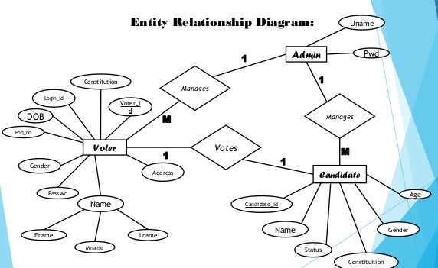

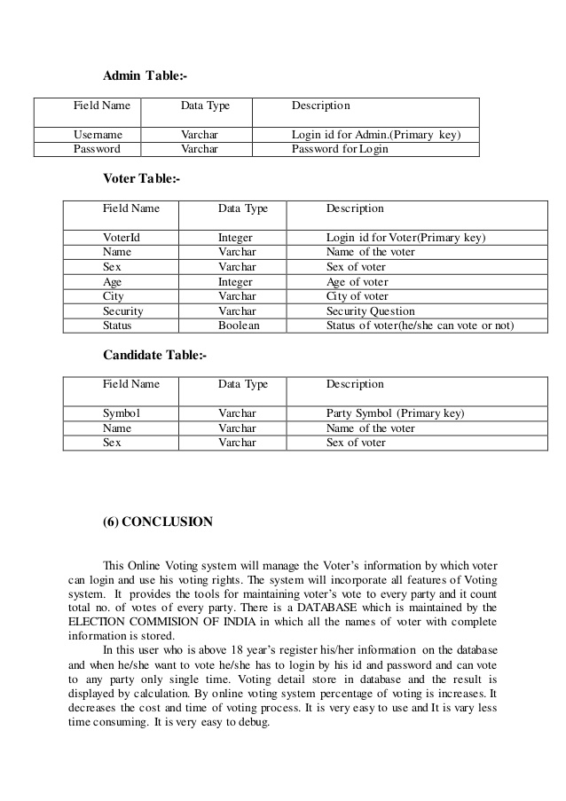**Schema Table**

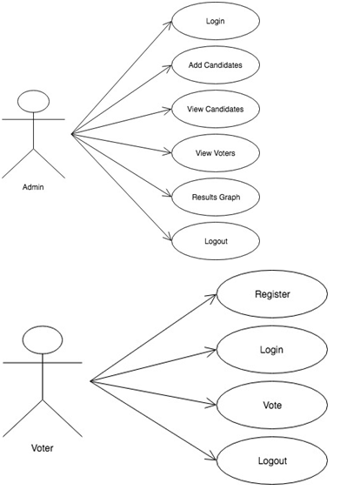 **Case Tool Diagram**

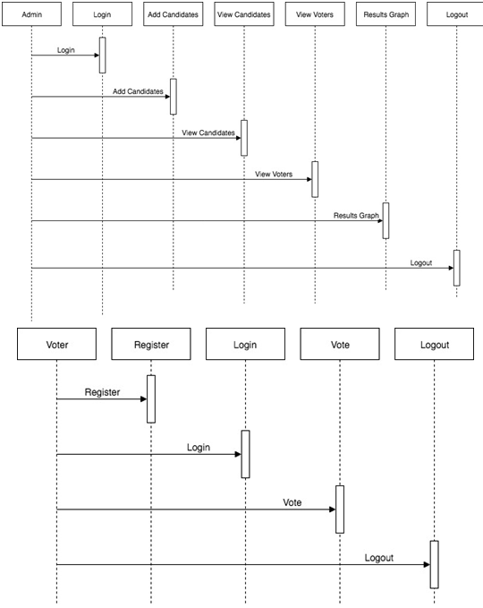 **Sequence Diagram**

**Class Diagram**

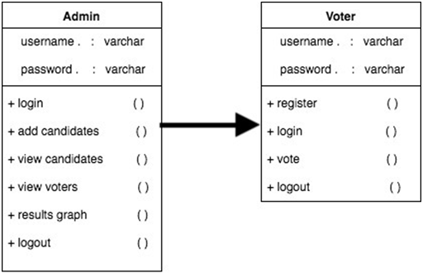

**Activity Flow Diagram**

Start

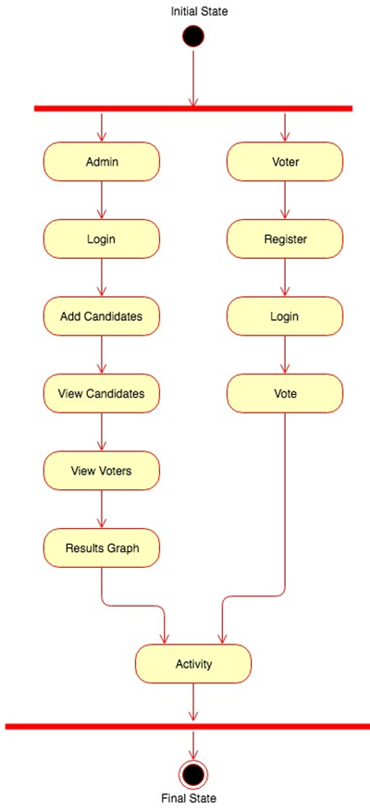

Stop

**Data flow diagram**

**Zero Level DFD**

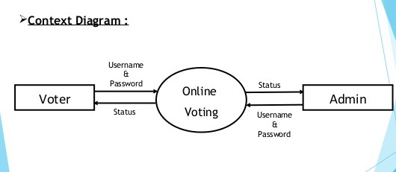

**First Level DFD**

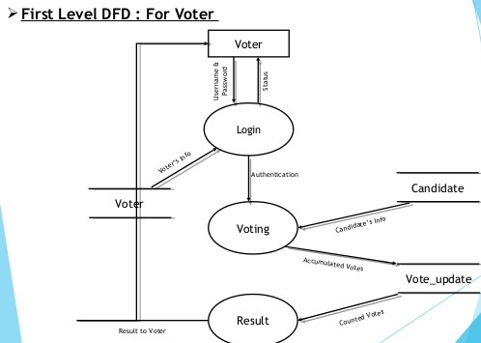

**Second Level DFD**

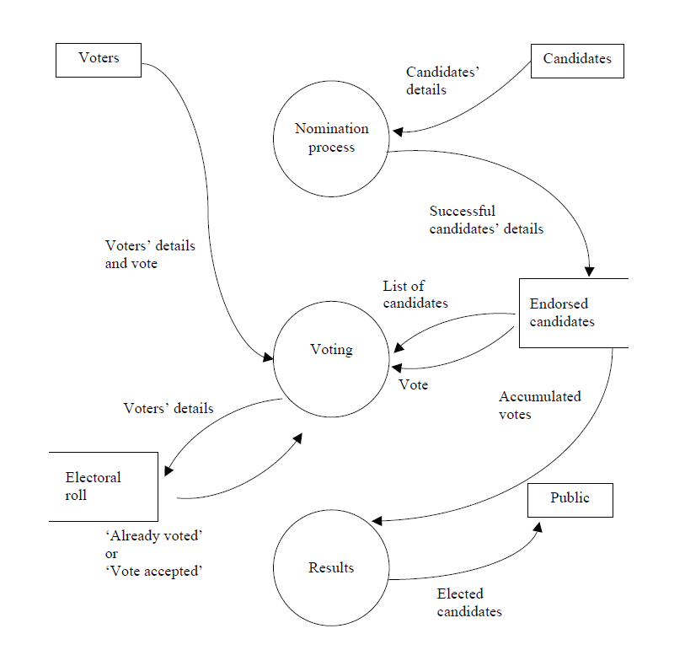

**Requirements**

* **Hardware Requirements Specification**
* **Processor :** Intel Pentium processor 500 MHz or faster
* **Ram :** Minimum 2 GB.
* **H.D.D :** Minimum 40GB or above.
* **Software Requirements Specification**
* **Operating System :**  windows xp or higher
* **IDE**  **:** Net beans.
* **Web Browser’s :**  Google chrome etc.

**Tools And Platform Used**

* **Front End**
* HTML, CSS, JavaScript,.
* **Back End**
* JSP, Servelt, MySQL, JDBC .

**Future Scope Of Online Voting System**

Everything requires modification and new implementation according to need or due to other reason. In the following proposed project following areas can be implemented in future.

• It is connected with the network for easily retrieved data and many location or many districts or cities in different states.

• All the information can be easily accessed the Voter like their details, voting status, poll result.

• Report on the different basis will be easy created on the demand.

• It can be modify and the others details can be easily provided to administrator.

• Option for customizing environment.

• New security features. With its emphasis on a more strategic decision making process is fast gaining ground as a popular outsourced function.